NERP TE project metadata submission to e-Atlas (May 2013)
Eric Lawrey, e-Atlas, Australian Institute of Marine Science

What is the metadata about and how will it be used
Over the life of the NERP TE program each project is required to complete a metadata describing the project itself and metadata records describing each of the dataset produced by the project.
This guide describes the creation and supplying of metadata describing just the project itself (referred to as the 'project metadata record') and not the datasets produced by this project; these will come later as each dataset is developed. These subsequent dataset records will be attached and linked to the project metadata record being described here.
Once the project metadata records are be finalised they will be added into the e-Atlas metadata catalogue and will be subsequently exported to the national catalogue (Research Data Australia) and discoverable through Google.
The primary purpose of the project metadata records is to act as a road sign for your research to ensure that it is discoverable when someone searches for a relevant topic.

Content of the metadata
The key parts of the project metadata are the abstract (what work and outcomes are being produced by this research), purpose (why is this research being done) the spatial extent (where is the research being done) and the contact information (who is doing the research).
The draft text for the project abstracts were developed from the project fact sheets and the project schedules. The metadata should be more detailed and specific then the project fact sheets describing what tasks the project is undertaking along with the methods being used to achieve the result. The key audience for these records is other researchers, not the wider community.

Video Guide
The steps for completing the project metadata records outlined in this guide are also available as a short screencast video (6 min) on Vimeo (http://vimeo.com/eatlas/nerp-te-project-metadata-guide). This video includes a quick guide for using Google Earth to create KMLs describing site locations and polygons. If you need to produce a Google Earth KML and are having some troubles this video may help.
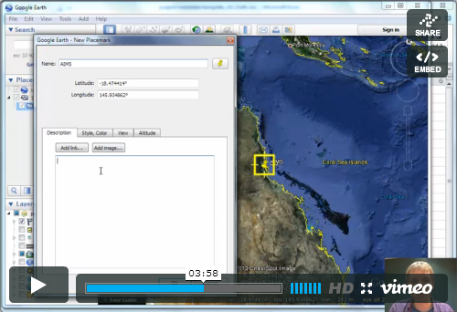

Steps for completing the project metadata
Each project will be emailed the project metadata excel template, prefilled in with details for their project. This information needs to be checked and corrected if necessary. Projects MUST also supply information about their spatial extent (site locations, areas worked, area analysed). Please ONLY edit the column corresponding to your column. Edits to other projects will be ignored when the records are collated.

1. Project abstract (description)
Review the description of the project. It should provide a short introduction to the project and describe the main activities of the project, along with an indication of the methods being used to achieve the outcomes. It should also mention the names of areas that are being studied and sufficient text and keywords to ensure that the records are discoverable via text searches.
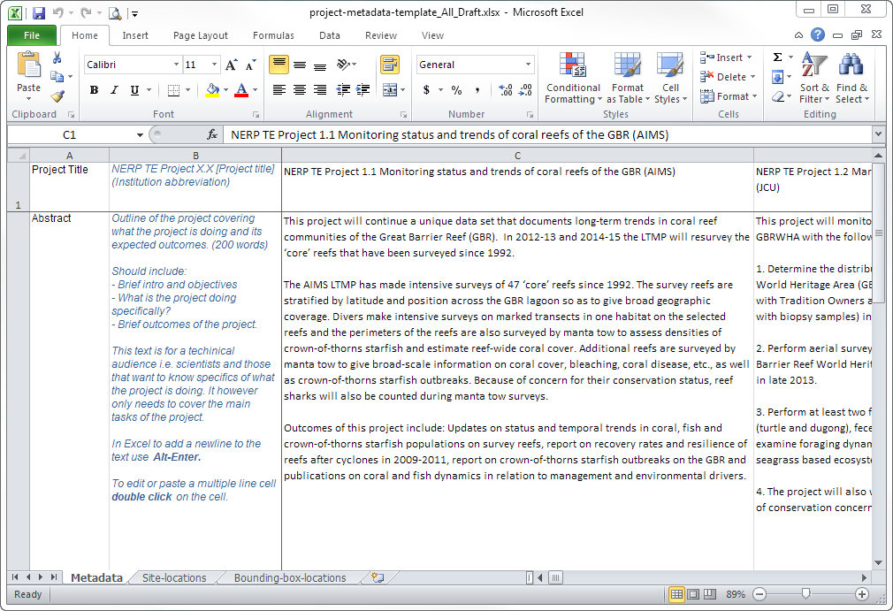
Figure 1 Preview of the Excel project metadata template

2. Contact information
The purpose of the contact information is to enable those interested in the work to contact the researcher. For these records the principal investigator will also be marked as the point of contact in the final metadata records. If you don’t wish this please provide the details of the point of contact.

3. Project spatial extent
The spatial extent of the project should describe the areas that the various activities within the project. This information will be used to allow spatial searching of research so that someone can answer the question, "what research has been done in this area or location that I am interested in". We will also use this information to create a map of the all the NERP TE Hub research that is being undertaken.
This information can be provided in a number of ways:
- Site locations in a spreadsheet (or csv) or Google Earth KML or KMZ (see how to create a KML below). For spreadsheets or csv it should have columns with latitude, longitude, site name, site description. The description field should describe what type of work or measurement is done at the location for example: “Manta tow survey” or “Temperature Logger” or “Invertebrate survey”. The Site-locations sheet of the project-metadata-template spreadsheet can be used to fill in this information if you don’t already have this information in another form.
- Regions of the study as a polygon supplied as a KML or shapefile. This is appropriate if for example you are studying the coastal area, or perhaps sea bird tracks, or coastline turbidity, or if you don’t know or don’t wish to provide the exact study sites but can provide details for the general region being worked in.
- One or more bounding boxes of the study locations, supplied as a spreadsheet with northlimit, southlimit, eastlimit, westlimit, region name, description. The bounds should be provided in decimal degrees. This can be provided in the Bounding-box-locations sheet of the the project-metadata-template spreadsheet.
If the project has multiple parts to it, each with a different spatial extend you can mix and match how you provide the information.
If you have high precision site information, but wish to reduce the spatial accuracy to protect the exact location of the site then please indicate this in the project abstract. The easiest way for this to be done is to reduce the precision of the latitude and longitude coordinates.
Example Latitude | Approx. Error
-19.8364 | 10 m
-19.836 | 100 m
-19.83 | 1 km
You can also provide the information as a set of bounding boxes instead of points. The span of the bounds provides a better indication of the level of error in the spatial information.
If necessary this reduction in the precision can be done by the e-Atlas team, just let us know the level of acceptable error and the reason for the protection.

Creating KMLs in Google Earth
If you don’t already have a record of your sites or region in some existing form (KML, spreadsheet, csv or shapefile) you can create them using Google Earth.
- Download, install and start Google Earth (http://www.google.com/earth/), if you don’t already have it.
- Zoom to your region of interest.
- If you have multiple sites or polygons you should create a folder for all the features to be grouped together. This makes saving them all easy.
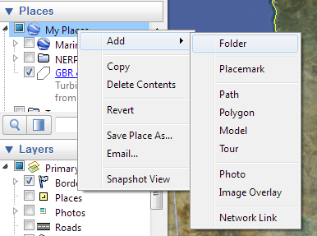
Call it something like: NERP-TE-Project-1.4-sites

- Select the folder then use the Add Placemark 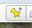 to add points, or Add Polygon 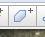 to add a region. If you create features (points or polygons) outside of the folder you can drag them into the folder using drag-and-drop.

For Placemarks it is placed in the centre of the screen. You can drag it around to position it, or type in the coordinates in the popup dialog that appears. Give the site a useful name, such as the site name. If you add a description this will be included in popups generated when someone looks at your site in the e-Atlas.
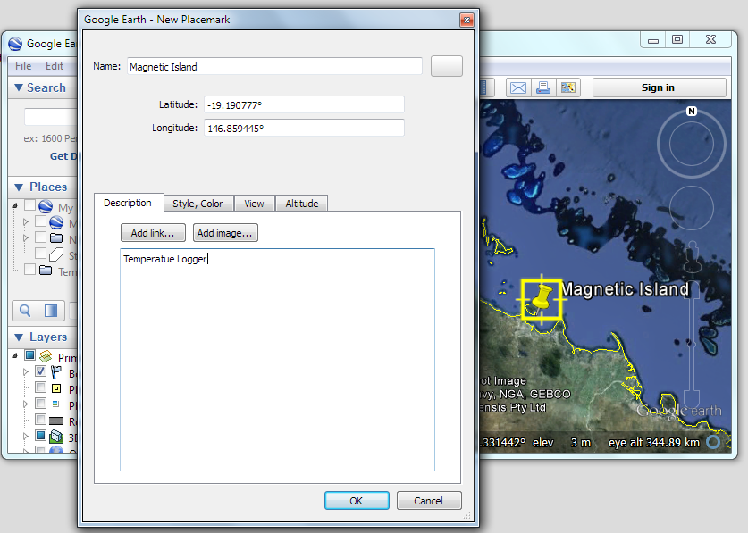

For polygon regions you don’t need to be overly precise the coastline for example. The main aim is to provide better information than simply a bounding box.

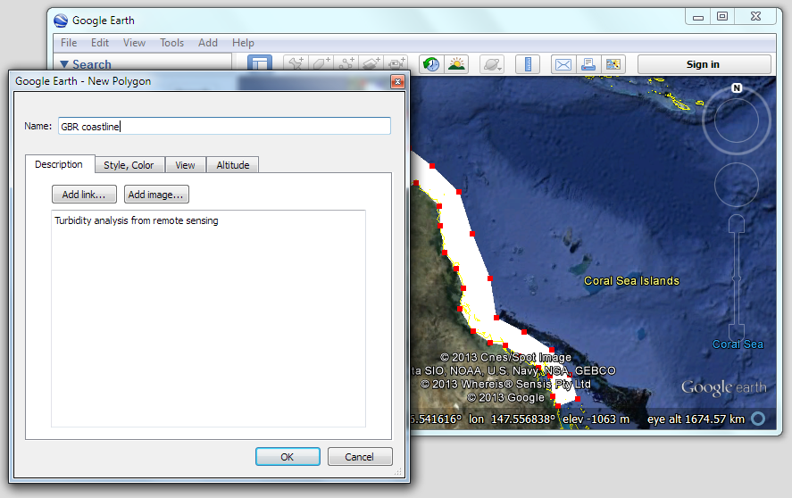
- Once you have added all your points or polygons, right click on the folder you created for the project and select Save Place As…
