Glider deployments.
What are ocean gliders?
Ocean gliders are unmanned underwater vehicles that can collect several different measurements. They are reusable and can be remotely controlled, making them a relatively cost-effective method for collecting repeat ocean observations of the water column. The gliders’ position can be controlled, allowing precise sampling of particular features of interest. In this case, a marine heat wave. You can find some news on the Tasman Marine Heatwave in the news! https://www.theguardian.com/environment/2019/mar/05/australias-marine-heatwaves-provide-a-glimpse-of-the-new-ecological-order

Because gliders are unmanned they can work around the clock in all weather conditions continuously sampling the water for temperature, salinity, dissolved oxygen, chlorophyll and turbidity.
The Slocum glider, which has been deployed in the East Coast of Tasmania, performs multiple dive-ascent cycles continuously going up and down the water column (see figure 1). After several cycles, it surfaces again to transmit a sample of data by satellite and to receive new instructions from the base station. It also records its position and time stamp before diving into the next segment of up-down-up sampling cycle. The glider can sample up to 200 m depth, and can last in the water for ~20 days.

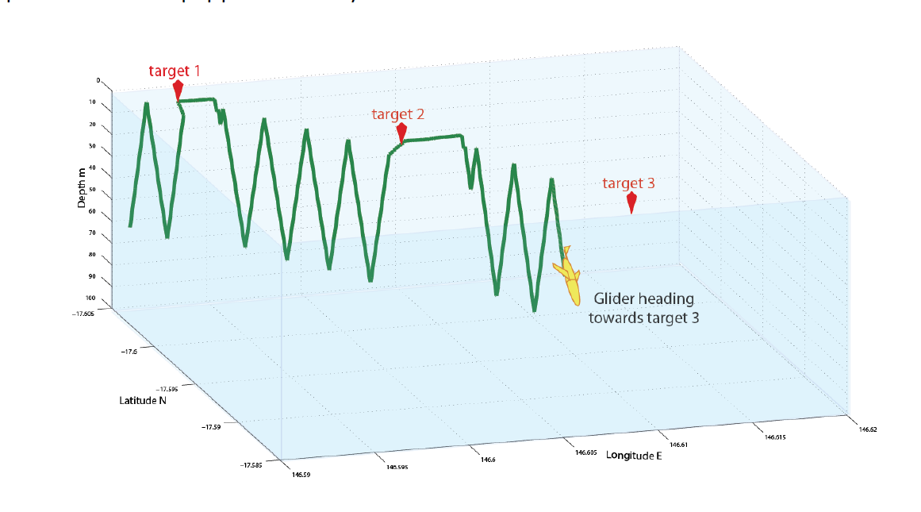

IMOS has deployed a glider on the East Coast of Tasmania to have a look at the current Marine Heatwave. As you can see from the news item from the link above, marine heatwaves are extreme regional ocean warming that can have big impacts living creatures in the ocean and their habitat.

You can access the data from the glider in real time, giving you a window of what is happening through the water as this marine heatwave continues to move and develop. There are three different ways to access the data.
1 Directly from the IMOS glider website at the University of Western Australia: http://anfog.ecm.uwa.edu.au/
2. Using the IMOS OceanCurrents website http://oceancurrent.imos.org.au/

You can also visualise the data using GoogleEarth if you would like to do that.

INSTRUCTIONS TO SEE THE REAL TIME GLIDER DATA
To see the data directly from the IMOS glider website, go to the UWA website http://anfog.ecm.uwa.edu.au/ where you will see a map of the gliders. Click on the glider of interest, in this case is: unit281 (TasEastCoast-13Feb19).

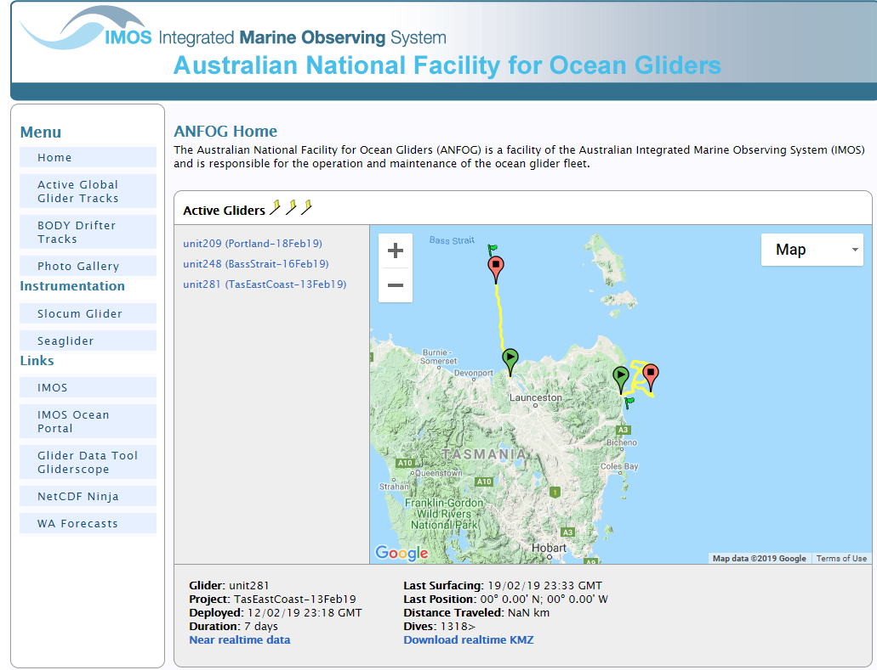
Note that at the bottom of the page appears the information about the glider, click on the “Near realtime data” link. This will bring up the plots showing the observations collected by the glider through the entire mission

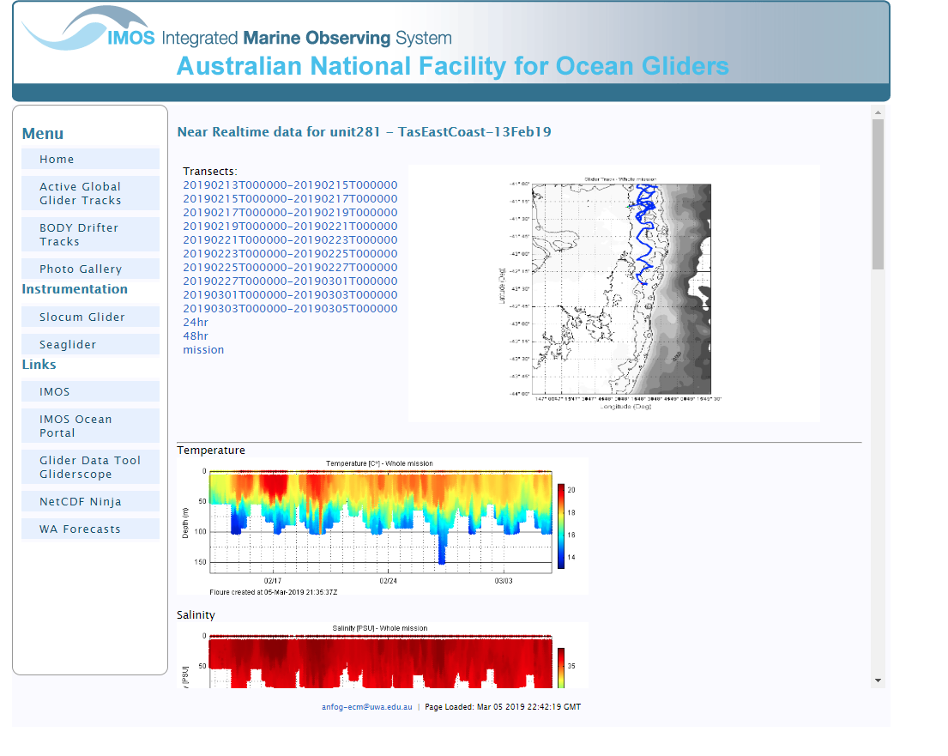
You can scroll down to see all the plots

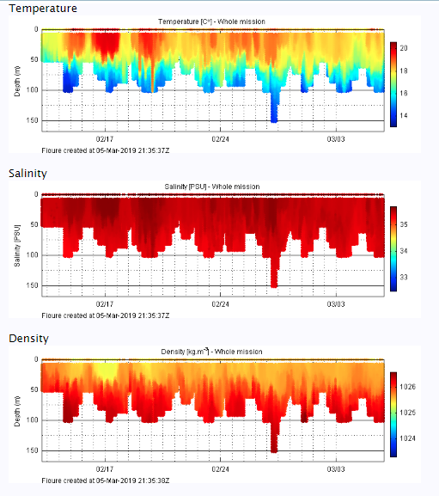
In the top plot, you can see how temperature is changing in the water column. You can see some pockets of warm water that go down to 50m in some places and up to 100m in others. At the bottom of the plots, you can see the date when the data was collected by the glider. Remember that this plot is for the entire mission. If you are interested in a particular section you will need to select it at the top of the screen.
For example, I selected the second last section of the glider mission, and below you can see the plot for that section only. Notice that the plot starts with a depth of 100m and then the depth decreases, this is because the glider is going from offshore towards the coast and then turns to go offshore again.
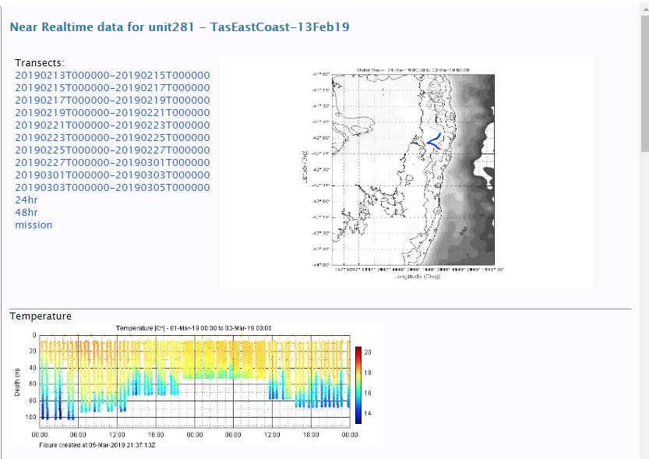

If you are interested in seeing what the currents are doing the best source is IMOS OceanCurrent website http://oceancurrent.imos.org.au/index.php

Go to the website and on the right hand side choose Gliders (red rectangle)

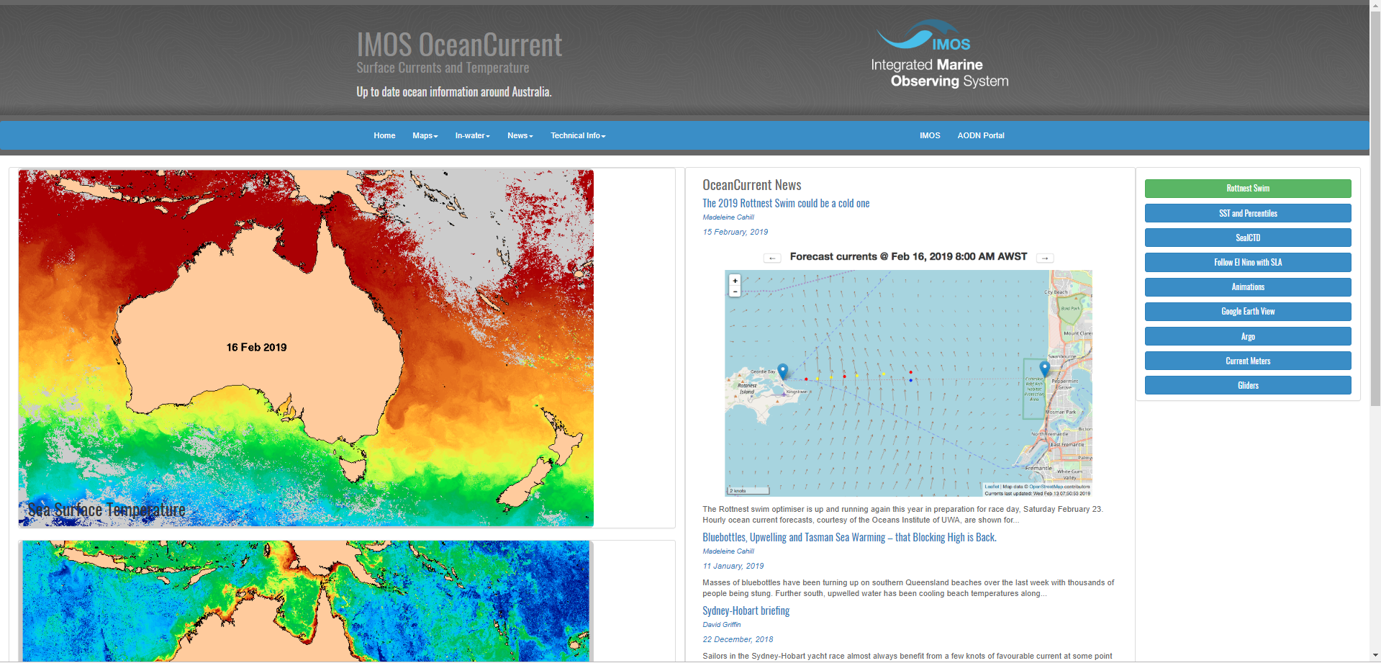

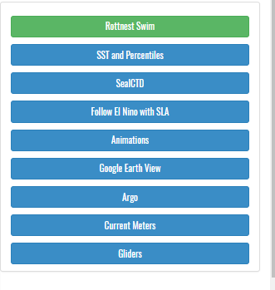
This will take you to a page where you can see the many glider missions that are currently in the water or that have been in the water recently. Go to the Slocum Gliders missions (middle panel) and click on it to expand
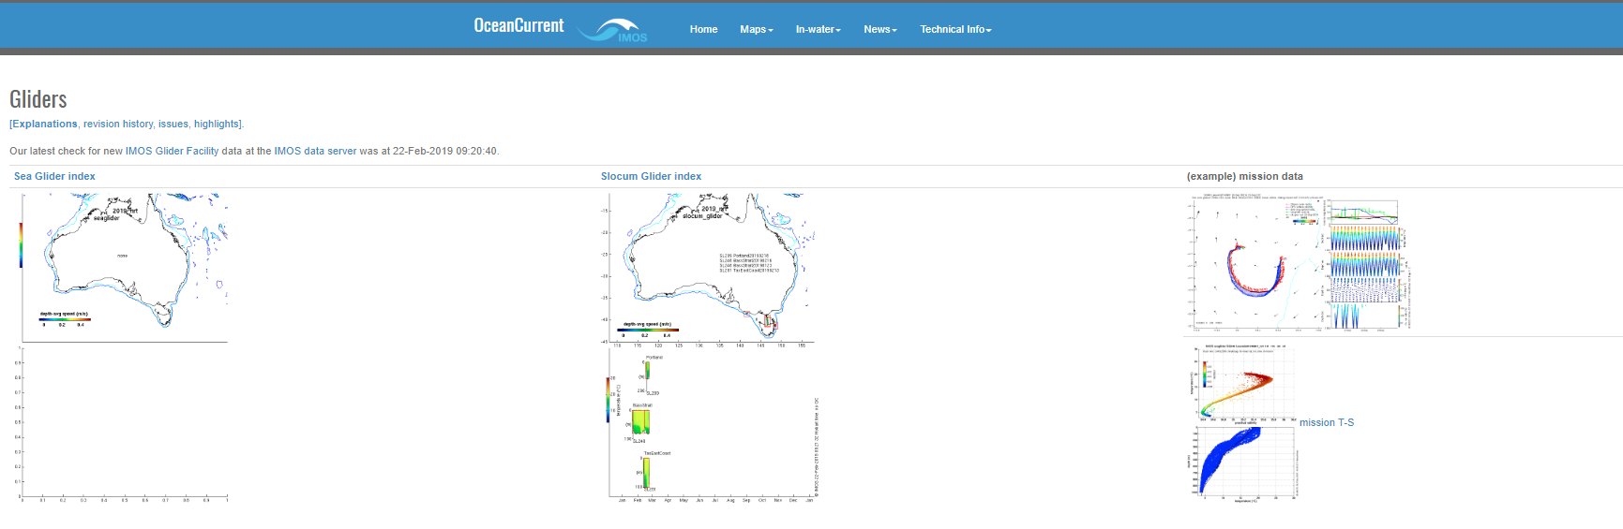
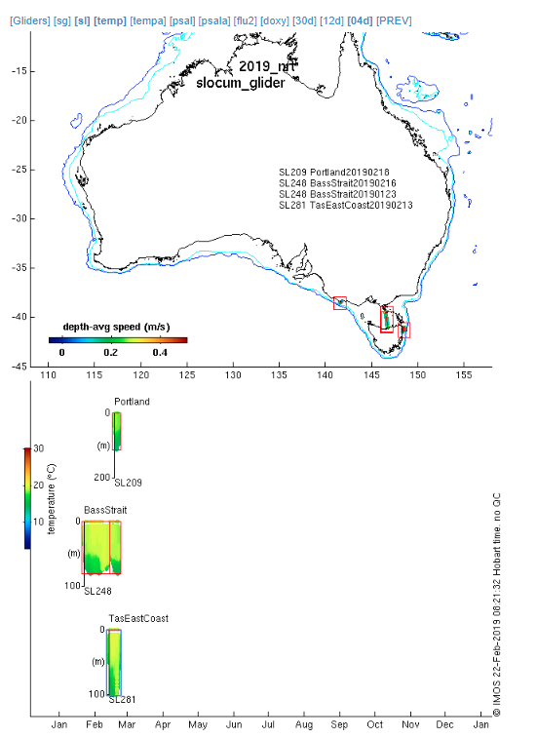
You can now select the glider deployment of interest, in our case TasEast Coast (red arrow)

Once you click on this you will see on your left-hand side a map with the east coast of Tasmania, and some of the glider track. The blue arrows represent the currents, the size of the arrow is the magnitude (or strength) and the direction of the arrow is where the current is going. At the top of that map (in the red square you can go back in time using the [PREV] and [NEXT] links so you can see the progress of the glider track and the different velocities.
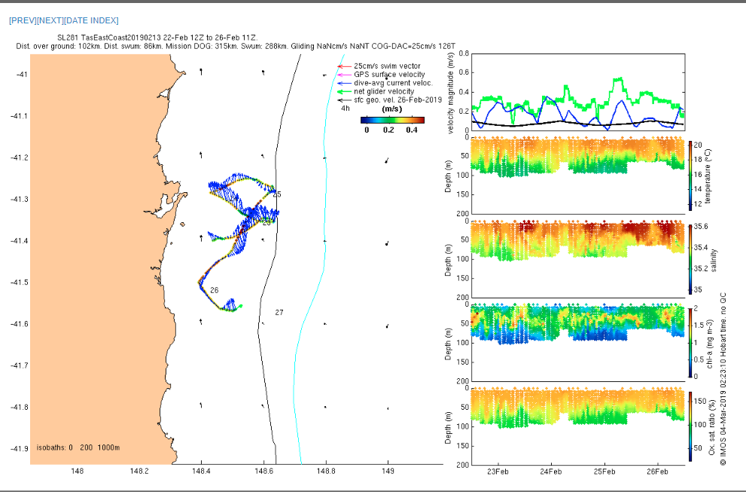
On your right hand, you will see plots from top to bottom: velocity, temperature, salinity, Chlorophyll a (which could be use as a proxy for phytoplankton) and oxygen.
The blue line in the velocity plot is the dive averaged current velocity. Because the glider goes up and down the water column collecting information, the average velocity is estimated over that up-down cycle. The green line is the velocity of the glider.

If you would like to see more of what is happening off the coast of Tasmania you can explore more through the OceanCurrents website where you will see the satellite sea surface temperature and currents estimated from satellite data.
